worksheet 30: Binary Search Tree Iterator Name:

**Worksheet 30: Binary Search Tree Iterator**

**In preparation**: If you have not done so already, complete worksheet 29 to learn the basic features of the binary search tree.

To make the BST a useful container we need an iterator. This iterator must produce the elements in sequence. As we noted previously, this means making an in-order traversal of the tree. Examine the following tree and see if you can guess an algorithm that will do this. Remember that, in our implementation, nodes do not point back up to their parent nodes. How will you remember the path you have followed down the tree?

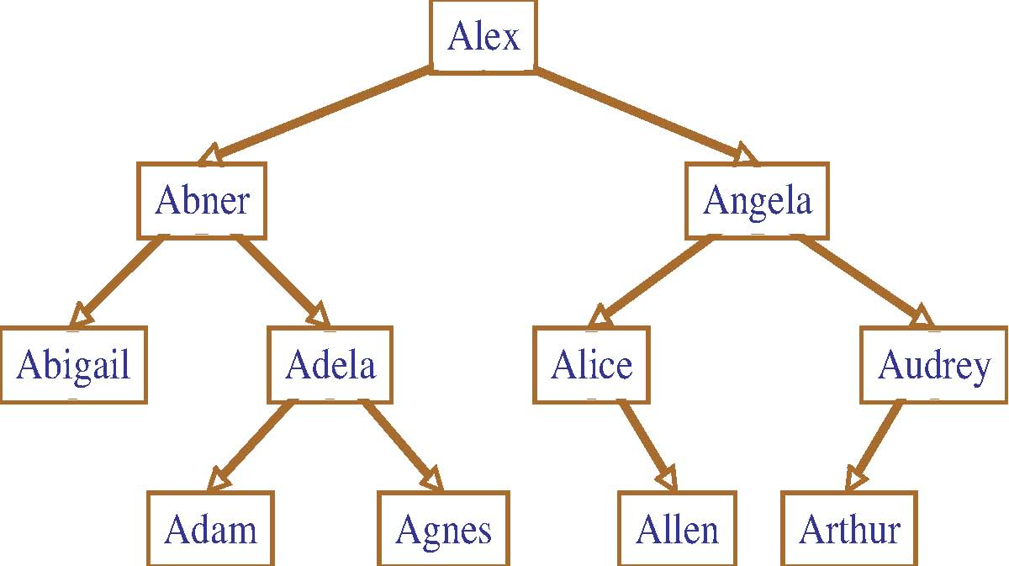

As you might have guessed, one way to do this is to have the iterator maintain an internal stack. This stack will represent the current path that has been traversed . Notice that the first element that our iterator should produce is the leftmost child of the root, and that furthermore all the nodes between the root and this point should be added to the stack. A useful routine for this purpose is slideLeft:

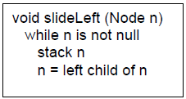

Using the slideLeft routine, verify that the following algorithm will produce the desired iterator traversal of the binary search tree. The remove portion of the iterator interface is more complex, and we will not consider it here.

BSTIteratorInit  
to initialize, create an empty stack   
 int BSTIteratorHasNext  
 if stack is empty   
 perform slideLeft on root   
 otherwise  
 let n be top of stack. Pop topmost element.  
 slideLeft on right child of n   
 return true if stack is not empty   
  
double BSTIteratorNext   
 let n be top of stack. Return value of n

Can you characterize what elements are being held on the stack? How large can the stack grow?   
  
The nodes are being held in the stack. The stack can grow to the size of the tree.   
  
Assuming that we have already defined a Stack that will hold pointers to nodes, show the implementation of the functions that implement the iterator algorithms described above.   
  
  
struct BSTIterator {  
 struct DynArr *stk;  
 struct BSTree *tree;  
};   
void BSTIteratorInit (struct BSTree *tree, struct BSTIterator *itr) {

Itr->tree = tree;

initDynArr(itr->stk, tree->size / 4 + 1);

}

int BSTIteratorHasNext (struct BSTIterator * itr) {

struct Node topNode;

if(isEmptyDynArray(stk)){

slideLeft(tree->root, itr);

}

Else{

topNode = dynArrayPop(itr->stk);

slideLeft(topNode->right);

}

if(!isEmptyDynArray(stk)){

return true;

}

Return false;

}

TYPE BSTIteratorNext (struct BSTIterator *itr) {

Return topDynArray(itr->stk);

}

void _slideLeft(struct Node *cur, struct BSTIterator *itr)   
{

While(cur != null)

{

dynArrayPush(Itr->stk, cur->val);

cur = cur->left;

}   
}